eService R5 ClickOnce Deployment Guide

Prepared By Ilzat Yusup  
  
  
Date created: June 29, 2016

# Deploy WCF services

# Get the latest version and rebuild the solution

# Update following settings in web.config file

* + - defaultMailto: eServiceProdAlerts@1961531albertaltd.com
    - applicationContext : production
    - cachePath: C:\EServiceR5Data
  1. Deploy it to sanjel04.snj.local as 5.X.X.X
  2. Verify the WCF service deployment is correct via  [http://sanjel04.snj.local/EServiceR5WCFServices/5.X.X.X/BinService.svc](%20http://sanjel04.snj.local/EServiceR5WCFServices/5.X.X.X/BinService.svc)

1. **Client Deployment**
   1. Change the App.config file for SanjeleServiceProduction
      1. **EServiceBaseAddress**: http://sanjel04.snj.local/EServiceR5WCFServices/5.X.X.X
      2. **defaultMailto**: [eServiceProdAlerts@1961531albertaltd.com](mailto:eServiceProdAlerts@1961531albertaltd.com)
      3. **smtpServer**: 1961531albertaltd-com.mail.protection.outlook.com
      4. **applicationContext** : production
      5. **cachePath:** %HOMEPATH%\Applications\EServiceR5Data
   2. Make sure **SanjelServiceProduction** project includes **Configurations** folder which includes Price Book printing related xml files and logo.

# Update Client Publish Location, Installation Folder URL , Client Version Number, Application Files

* Right click “**SanjeleServiceProduction**” , on the Project menu, click **Properties**.
* Click “**Publish**” tab and in the update “**Publish Location**” field enter the publishing folder location. Here is the format:
* \\sanjel04.snj.local\c$\inetpub\wwwroot\EServiceDeployment\eServiceR5\ Update Installation folder URL. Here is the format:
* [http://sanjel04.snj.local/EServiceR5/](http://sanjel04.snj.local/EServiceR5/%20)
* Check the “The application is available offline as well” radio button.
* Click “Application Files..” button and make sure files under the Configuration folder publish status’ are **“Include”.** See the screen shot in below:

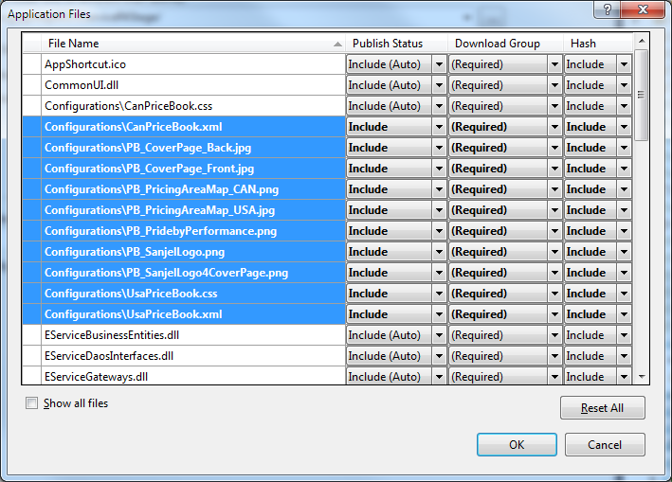

* Click "Publish Now" button or “Publish Wiard..” to deploy it to server. After the publish is done successfully, a web page of installation will pop up.
  1. Sign eService client using Manifest Generation and Editing Tool
* Remotely open the application deployment folder on the server, e.g. \\ServerName\c$\inetpub\wwwroot\EServiceDeployment\eServiceR4Product\
* Right-click on SanjelEService.application, click on "Open With" -> "Manifest Generation And Editing Tool"
* Manifest window will pop up, click on "Deployment Options", select "**Application Type**" as "**Install Locally**", input "**Start Location**" in HTTP format, e.g. http://ServerName/EServiceR5Prod/SanjelEService.application
* Close the window, Click "Yes" button as a saving message box pop up.
* "Signin Options" window will pop up.
* Select radio button "Sign with certificate file", click on the "..." button after the File textbox to browse your local project folder, select the proper certificate file which with .pfx extension.
* Then click "Open". Input password.
  1. Test the new deployed client.